**OPERATING SYSTEMS (QUESTION BANK)**

**UNIT 1**

1.Explain Operating System structures.

2.Explain different types of OS components.

3.Operating System services.

4.Explain features of LINUX operating System.

5. Briefly explain Linux file system.

6.What are different types of LINUX UTILITIES

7.Explain( example :file handling utilities, process utilities, Disk utilities ).

8. Define Operating system,

9.What iskernel.

10.What is real time OS.

11.Explain different types of OS.

**UNIT 2**

1.What is shell? Explain different types of Shell.

2.Explain the shell programming/shell script with simple example.

3. Explain process life cycle with neat diagram (process state diagram).

4.Mention differences between preemptive and non preemptive scheduling with example.

5.What is cooperating process? Explain various operations performed on processes.

6.What is context switching? Explain.

7.What is thread? Explain differences between process and thread.

8.What is CPU Scheduling? Explain various types of CPU scheduling algorithms with examples(FCFS, SJF, Priority, Round robin, Preemptive version of SJF is calledSRTF(shortest remaining time first).

* Preemptive SJF scheduling is called SRTF.

9.What is long term, medium, short term schedulers.

10.Explain scheduling criteria. What is multiple processor scheduling.

11.Define Thread.

**UNIT 3**

1.What is deadlock? Explain deadlock characterization.

2.Explain methods for handling deadlock.

3.Explain Bankers algorithm in detail.

4.write about deadlock prevention and avoidance measures.

5.Explain deadlock detection and recovery from deadlock.

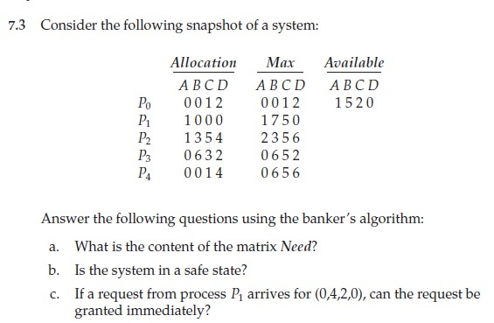

7.Define safe state,assigned edge,request edge,use of resource allocation graph.

8.Explain in detail about process synchronization.

9.Explain critical section problem.

11.Explain classical problems of synchronization(Dining philosophers problem, Producer consumer problem, Reader writer problem).

12.What is critical region/critical section? What is monitor.

13.Explain semaphore.

**UNIT 4**

1.Explain inter process communication.

2. Explain the following

a.shared memory.

b.message queues.

c.Named pipes(FIFO pipes).

3.Explain logical versus physical address space.

4.Explain swapping,contiguous allocation of memory.

5.Write about paging, segmentation, segmentation with paging.

6.What is demand paging? Explain.

7.Explain various page replacement algorithms with example problems(FIFO,LRU,OPTIMAL)

8. consider the following reference string 1,2,3,4,2,1,5,6,2,1,2,3,7,6,3,2,1,2,3,6

How many number of page faults would occur for the following page replacement algorithms assuming three, four frames? Assuming that all frames are initially empty.

a.FIFO Replacement algorithm

b. LRU replacement algorithm

c. optimal replacement algorithm.

9.Define the following page fault, page fault ratio,Hit ratio,Virtual memory, BeladysAnamoly.

**UNIT 5**

1.Define file system interface and operations.

2.Define each directory structure, protection, file system structure.

3.Explain different file allocation methods.

4.Explain kernel support for files.

5.Explain various disk scheduling algorithms with examples.(FCFS,SSTF,SCAN,C-SCAN).

6.Consider for example a disk queue with requests for I/O blocks on cylinders 98,183,37,122,14,124,65,67 .If the disk head is initially at cylinder 53.Find the total no.of head movements for the following disk scheduling algorithms.

a.FCFS disk scheduling.

b.SSTF disk scheduling.

c.SCAN disk scheduling.

d.C-SCAN disk scheduling.

7.Define file mounting.

8.Define seektime,Rotational latency.